**Site Plan - Airotciv.com**

**Overview**

*Airotciv.com* is a website that is designed to give party planners a workspace to display their advertising to event planners. It will display events that have been previously planned, what type of events that can be planned and a small blog section that allows users to view post and comment on the events in the web development area.

*Airotciv.com* has a prime focus to make party planning easier and effective for those looking for a party planner and looking to have the best representation for their event. This website will make it easier to plan events without the hassle of looking for a party planner. It allows the person that is planning an event to be able to view what their event can consist of and describe what their experience is.

The site will be primarily static in nature and built from the bottom up. It will have pages of content describing the types of events that can be planned, blogs, reviews, posts of events that are coming up, contact information and it will focus on mobile friendly responsive designs.

**Goals**

The primary goals of the site and corresponding objectives are given below.

**Generate Prospective Client Interest**

* Increase business relations via email, phone, or online.
* Increase traffic by use of the blog which contains reviews and posts of clients’ experience
* Prevent time being wasted by in person contact
* Client can detail their wants.
* Maximize user session duration and page views

**Promoting Professional Profile of site**

* Increase the number of page views / foot traffic on site
* Making page popular by referrals and viewings of the posts and comments which allows the client to decide

**Target Users**

There are two user categories that are expected to make up the bulk of traffic to dms.com.

**Sam – Event Manager/ Planning and Marketing director**

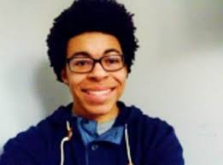

Sam is a 26-year-old Event Manager for PWU which is a sponsored company that collaborates with corporations such as party city and Party Depot. He has previously attended Western Connecticut State University where he majored in business and received a master’s degree in business analytics and project management. He always gets clients that want various things for their event which he tries to provide. He will find my page on a social site and will arrive at *Airotciv.com* and be able to start the event planning from there.

When he visits my page, it will detail events that have been planned with the reviews and comments that people have put on my site. He will be able to pick out the top of line products for the events. He can utilize the contact section to create and plan the event.

**Will – Director of Marketing/ Community Relations**

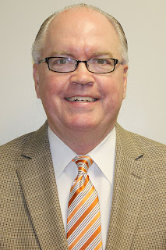

Will is a 55-year-old Director of Marketing/ Community Relations for NEMCC. He hosts sport events for the Northeast Mississippi Community College. He will find that using this site will help to expand communication between the teams and the spectators or fans. He often sets events in person with an event planner but by browsing the site he will discover that there is easy access for him to create an event with the web site. It would also be able to be used on mobile devices.

Will needs a faster and effective way to plan events and advertise for sporting events or getting members of the community together.

When he visits my page, it will detail events that have been planned with the reviews and comments that people have put on my site. He can utilize the contact section to create and plan the event.

**Content**

**Home**

This will be the first access point of the site for visitors and viewers of the site. There will be other images, my name and a mission/ goal statement for what the website lives by.

**About**

This page will reference the websites motto as well as inform the viewers on what the website can help them with when planning an event or looking for an event planner. It will explain the business and the products made to make the business effective.

**Blog**

This page will consist of lifestyle posts, comments and the reviews. A section for viewers to view and make their decision on whether they’d like to join the team or to express their experience with event website.

**Events**

This page will be an event calendar that shows when and where an event will occur.

**Donate**

This page will allow volunteers to help the website plan efficient events with funds. This section will allow the volunteers .to donate no more than 100 American dollars at a time.

**Join Us**

This page will allow the viewer to be able to join the team or become a creative member.

**Contact Information**

Contact information will have an area where it is always visible within the website. A contact form will also be accessible from this area.

**Similar Sites**

**maryisabelevents.com**

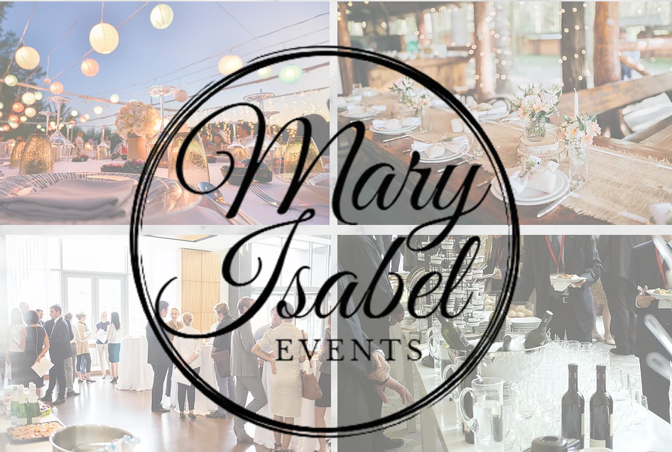

**eventective.com**



**eventbrite.com**

